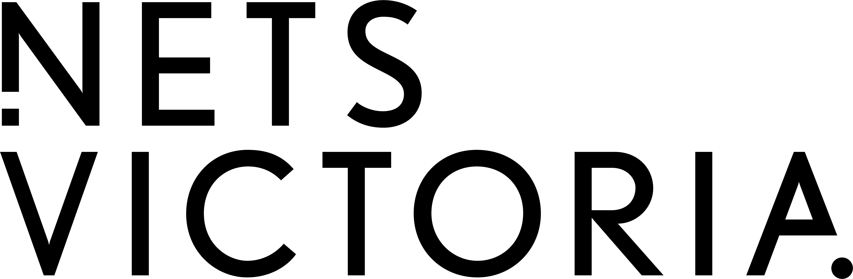

Exhibition Development Fund (EDF) Guidelines

Closing date: 5pm on the date as published on NETS Victoria’s website.
Up to $40,000 available

About
NETS Victoria’s Exhibition Development Fund (EDF) provides seed funding to research and develop new, curated exhibitions of contemporary visual arts, craft and design.
Projects may be entirely research and development and/or include a public outcome (such as staging the exhibition in a single venue or online, and/or producing an exhibition catalogue).
Applications ranging from $5,000 and $40,000 will be considered (from a total funding pool of $40,000). Project proposals at all stages of development are accepted, however projects requesting over $10,000 must have a public outcome in Victoria.

Accessibility

NETS Victoria is committed to ensuring our programs are accessible and inclusive. If you require this information in an alternative accessible format, or wish to apply using an alternative accessible format, please contact us on 03 8620 2007 or by emailing info@netsvictoria.org to discuss your requirements.

Purpose
The program supports innovative exhibitions of high-quality work and accompanying public programs that engage, inspire and develop artists, curators, arts organisations, public galleries and audiences across Victoria (and beyond).
It also aims to increase representation of First Nations artists and curators, showcase new and diverse voices, build capacity of artists, curators, applicants and audiences, create new touring models that contribute to environmental sustainability and increase the inclusivity and accessibility of exhibitions.
All projects must be developed with the intention to tour the exhibition in partnership with NETS Victoria. A NETS Victoria tour will help build your profile and professional network in galleries and communities across Australia, reach a wider audience, and capitalise on your investment in the project.

Eligibility

Applicants
EDF is open to independent curators and incorporated not-for-profit arts organisations in Australia (including Local Councils, public galleries, festivals and other arts organisations).
All applicants must have a history of supporting visual arts projects. If the applicant is an independent curator, they must have relevant qualifications and experience. They must either have their own ABN or be auspiced by an arts organisation with an ABN.
Independent artists and State-owned Government agencies are not eligible to apply. Applicants who have been part of a NETS Victoria tour in the previous three years are also not eligible to apply (whether that tour was supported by the EDF or not).
NETS Victoria board members and members of its Artistic Program Advisory Committee and Development and Fundraising Committee are eligible to apply. Should they apply, they cannot participate in any aspect of decision making.

Projects
Applicants may only submit one application for one project per round.
Applications can be for new commissions, exhibition research and curatorial development, which may or may not include a public outcome (such as staging the exhibition in a single venue, staging a digital exhibition or producing an exhibition catalogue). Projects requesting over $10,000 must have a public outcome in Victoria. If artists are being commissioned to make new artworks the following clause must be in the commissioning agreement:
“If the artwork is chosen to tour, the artist must continue to make the Artwork (The Work) available to NETS Victoria to loan for the duration of the tour. If the artist sells the Work before the end date of the tour, they must ensure that NETS Victoria is a party to the sale to the extent that it reasonably requires to protect its ability to borrow the Work for such touring from the purchaser. NETS Victoria will provide a loan fee for any touring works.”
Applications that include public outcomes must:
- Be open to the public at regular and/or specified times.
- Use gallery or non-gallery venues with environmental controls appropriate to the nature of the exhibition.
- Have good disability access (including step-free access to exhibition spaces and/or accessible digital programs or publications).
- Be restricted to a single venue or activity (not a multi-venue tour).
As the EDF is funded by Creative Victoria, the primary beneficiaries of EDF funded projects should be Victorian artists, curators, arts organisations, public galleries and audiences. However, exhibitions can include some interstate or international artists, and initial research, curatorial development and initial public outcomes may take place interstate. Projects requesting over $10,000 must have a public outcome in Victoria.
All activities must take place between 1 July 2023 and 30 June 2025.
Ineligible activities include:
- Exhibitions that have already been staged.
- Exhibitions that include more than 50% historical material.
- Exhibitions that include less than 50% living artists.
- Solo exhibitions of a deceased artist.
- Solo exhibitions of an artist that has had a NETS Victoria solo exhibition in the previous eight years from the date of application (whether that exhibition was supported by the EDF or not).
- Development of art prizes or awards.
- Development of permanent exhibitions or displays.
- Projects which will be academically assessed as part of the curator and/or artists’ studies.

Costs

Eligible costs include:
- Victorian-based Independent or external Curator fees (for research, development and artist liaison).
- Victorian-based Artist fees (including commission and loan fees at appropriate industry rates).
- Access costs.
- Research costs (including travel, accommodation and per diems).
- Contribution towards initial public outcome, such as:
  - Exhibition furniture, framing and technology.
  - Education, public program development and delivery.
  - Marketing, promotion, printing or digital platform delivery.
  - Documentation (including photographer, videographer and writer fees).
Ineligible costs include:
- Touring costs.
- Existing staff costs.

Selection Criteria

Applications will be checked for eligibility then assessed by the NETS Victoria Artistic Program Advisory Committee against the following selection criteria:

1. Artistic merit
- Quality of ideas and artwork.
- Quality of previous projects undertaken by artists and curators.
- Quality and innovation of curatorial rationale.

2. Strategic alignment
All applications should align with one or more of NETS Victoria’s strategic priorities, which are:
- Representation of First Nations artists and curators.
- Representation of new and diverse voices (as artists and/or curators).
By new voices, we mean people who may not have had an opportunity to have worked with our organisation, or across the visual arts, previously.
In our definition of diversity, we include people with disability, people of colour, d/Deaf and people from culturally and linguistically diverse backgrounds, LGBTIQA+ people, women, and people from regional/remote areas.
- Capacity building of Victorian-based artists, curators, arts organisations and audiences.
- Environmental sustainability and climate action.

3. Presentation, interpretation and reach
- Quality, reach and impact of public outcomes (if any).
- Tour-ability of concept and design, including:
  - Flexibility to be installed in multiple venues (of various types and scales).
  - Ease of installation and maintenance for galleries with limited staffing.
  - Potential public and education programs.
  - Evidence of how the concept or work responds or is relevant to an identified interest, need or audience.
  - Appropriate and accessible venues identified for public outcomes (where relevant).

4. Viability
- Capacity to professionally deliver the proposed activity and achieve the described outcomes to the highest possible standard.
- Realistic and accurate budget.
- Intention to tour the exhibition in partnership with NETS Victoria.

Conditions

1. Sole purpose
- The grant recipient must use the grant solely for the purpose for which it was approved.
- If any part of the grant is used for purposes other than those originally named, the grant recipient must inform NETS Victoria immediately. A variation agreement may be required if new purposes are approved.
- NETS Victoria reserves the right to terminate this agreement and request the return of funds should the grant recipient not adhere to these terms.

2. Compliance
- If the grant recipient is unable to undertake or complete the activity, NETS Victoria’s Board of Management reserves the right to terminate this agreement and request the return of part or all funds.

3. Acknowledgement
- All marketing material and publicity associated with the project must acknowledge the financial assistance of NETS Victoria using appropriate logos and credit lines on all publications.

4. Invitations
- Where relevant, 12 invitations to the opening of the initial public outcome must be forwarded to NETS Victoria for distribution to its Board of Management.
- The grant recipient will invite a NETS Victoria representative to speak at the opening or launch of the public outcome/s, where appropriate.

5. Preparation of other agreements
- This agreement is made on the understanding that the grant recipient will enter into standard contracts and loan agreements with all curators, artists and other practitioners involved in the project.

6. Acquittal
- The grant recipient is required to submit an acquittal report to NETS Victoria within one month of the project’s completion or 24 months after receipt of the grant (whichever comes first). This will include:
  - Overview of the project.
  - Benefits to the applicant, artists, curators and community.
  - Where grant activities included a public outcome:
    - Details of exhibition, public and education programs.
    - Attendance and diversity statistics.
    - Photographs, media clippings and promotional material.
  - Information and materials for NETS Victoria to apply for tour funding.

7. Liaison and intention to tour
- The grant recipient is expected to liaise with NETS Victoria throughout the development and delivery of this project.
- All EDF projects must be developed with the intention to tour the exhibition in partnership with NETS Victoria (pending confirmation of additional tour funding and future program priorities).

Application Process and Timeline

Applicants must read the EDF Frequently Asked Questions before submission.
Applications must include:
- Completed EDF Application and Budget Form
- Support material (in a single combined PDF document):
  - Biographies and website links (URLs) for all artists, curators and other practitioners (researchers, writers, etc.) involved in the project. No more than 150 words per person.
  - Images of each artists’ work with a minimum of 10 images of artworks per exhibition AND/OR website links (URLs) for up to 10 minutes of video work.
  - Up to 5 x A4 pages of written material, such as examples of curator’s written work, media articles, exhibition reviews, examples of publicity from previous projects (including source, date, and publication details).
  - Up to 3 x A4 letters of support that clearly articulate how the concept or work responds to an identified need, interest or audience. These could be from relevant organisations or individuals with specific knowledge of the concept behind the exhibition.
Applications must be emailed to info@netsvictoria.org by 5pm on the date of the deadline as published on NETS Victoria’s website.

NETS Victoria will notify applicants of their outcome by email. We reserve the right to grant partial allocations of funding to multiple applicants.
EDF funded projects must not commence before 1 July 2023. Funds will not be available until completed Grant Agreement is returned to NETS Victoria with a valid invoice.
Successful applicants will be required to submit an acquittal report to NETS Victoria within one month of the project’s completion or 24 months after receipt of the grant (whichever comes first).
NETS Victoria will use the 6-12 months after receiving the acquittal report to seek tour funding if aligned with future program priorities. If successful, a NETS Victoria tour will follow.
For more information, please contact NETS Victoria on 03 8620 2007 or info@netsvictoria.org.

NETS Victoria’s Exhibition Development Fund is devolved on behalf of the Victorian Government through Creative Victoria.
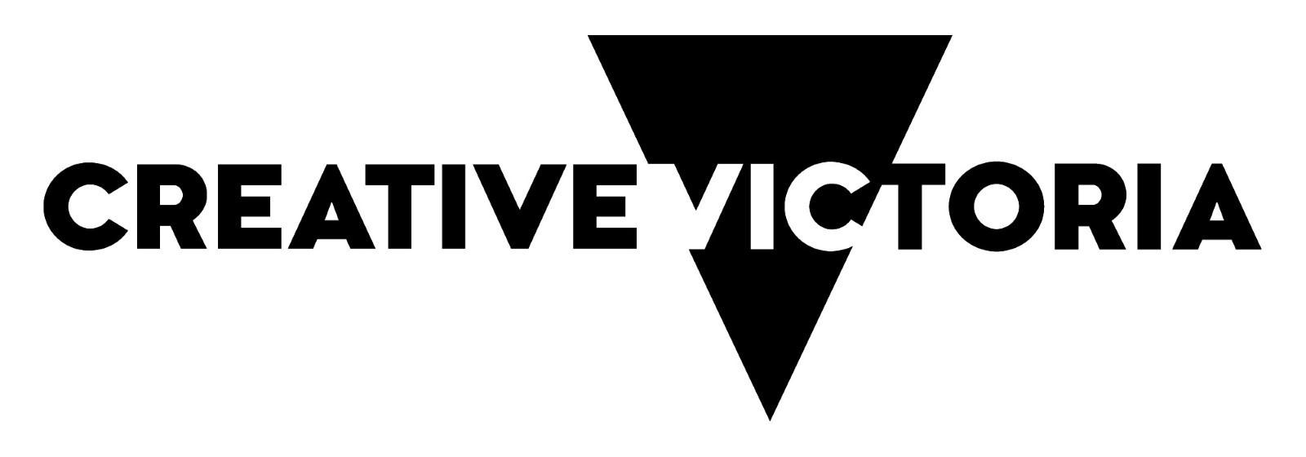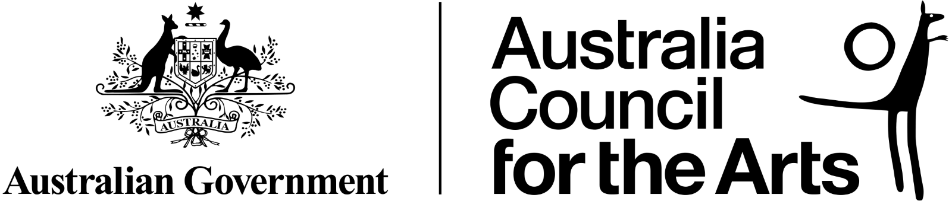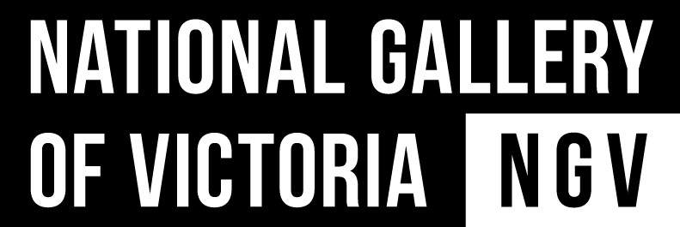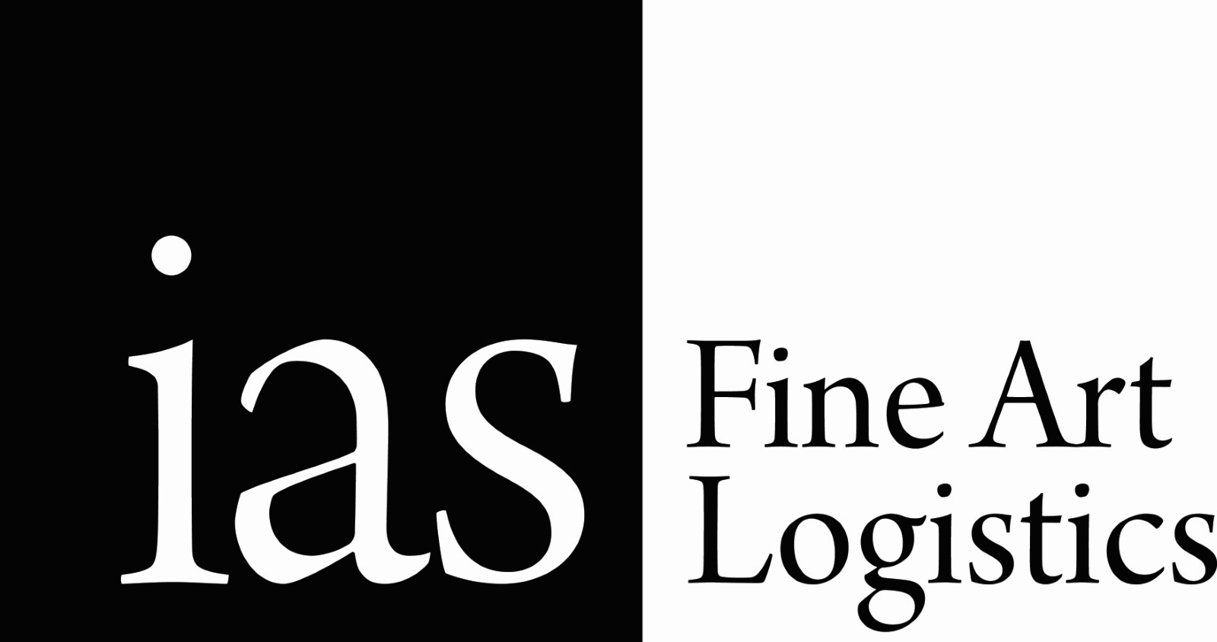
National Exhibitions Touring Support (NETS) Victoria is supported by the Victorian Government through Creative Victoria, by the Australian Government through the Australia Council, its arts funding and advisory body, and through the Visual Arts and Craft Strategy, an initiative of the Australian, State and Territory Government. NETS Victoria also receives significant in-kind support from the National Gallery of Victoria.

