Exhibition Development Fund (EDF)
Application and Budget Form

Applicants must read the EDF Guidelines and EDF Frequently Asked Questions before submission.
Applications must include:
- Completed EDF Application and Budget Form.
- Support material (in a single combined PDF document):
  - Biographies and website links (URLs) for all artists, curators and other practitioners (researchers, writers, etc.) involved in the project. No more than 200 words per person.
  - Between 5-10 images of artwork AND/OR website links (URLs) for up to 10 minutes of video work.
  - Up to 5 x A4 pages of written material, such as biographies, examples of curator’s written work, media articles, exhibition reviews, examples of publicity from previous projects (including source, date, and publication details).
  - Up to 3 x A4 letters of support from relevant organisations and individuals, which may include evidence of how the concept or work responds or is relevant to an identified interest, need or audience.
Applications must be emailed to info@netsvictoria.org no later than by 5pm on the day of the deadline published on NETS Victoria’s website.

Applicant Details
Contact person (name)
Contact person (title)
Pronouns
Organisation (if relevant)
CEO / Director (if relevant)
Address
Phone |  |  |  |  |  | Email
ABN
Type of applicant (independent curator, Local Council, incorporated not-for-profit public gallery, festival or arts organisation)
Auspicing organisation (if relevant)
Eligibility (applicants must answer ‘true’ to ALL of the following criteria to apply)
Applicant has a history of supporting visual arts projects and/or is an independent curator with relevant qualifications and experience.
Applicant is not an independent artist or State-owned Government agency.
Applicant has not been a partner with NETS Victoria for an exhibition tour in the previous two years. (This time period is measured as between the first date of the first tour venue of a previous exhibition to the submission due date of the current application round.)
Applicant has not submitted more than one application for one project in this round.
Applicant intends to tour the exhibition in partnership with NETS Victoria and agrees to provide relevant and timely acquittal content to NETS Victoria (to support funding applications).
Project beneficiaries are primarily Victorian artists, curators, arts organisations, public galleries and audiences.
Project activities will take place between 1 July 2023 and 30 June 2025
Project activities and costs are eligible (as per EDF Guidelines).
Project Summary
Title
Curator
Brief description of project
(Please note, if successful, this description will be used in a media announcement by NETS Victoria)
Up to 100 words

Brief description of public outcome/s (if relevant. Projects requesting over $10,000 must have a public outcome in Victoria)
Up to 100 words

Project Detail
Detailed description of project (including curatorial rationale, who is involved, and public outcome/s if relevant)
Up to 500 words

Project objectives and outcomes (including what you hope it will achieve and how it aligns with one or more of NETS Victoria’s strategic priorities)
Up to 500 words

Future potential (including tour-ability of concept and design, potential public and education programs, and target audiences)
Up to 500 words

Project start date
Project end date
Data (for internal purposes only)
How many Victorian based artists are involved in the project?
How many other Victorian based personnel are involved in the project? (Such as curators, writers and designers)
How many Aboriginal and Torres Strait Islanders are involved in the project (if any)? If known, please provide language groups where possible.
How many international First Nations people are involved in the project (if any)? If known, please provide cultural groups where possible.
How many culturally and linguistically diverse (CALD) people and/or People of Colour (POC) are involved in the project (if any)?
How many LGBTQIA+ people are involved in your project (if any)?
How many d/Deaf or Disabled people are involved in your project (if any)?
Budget
Please complete the EDF Budget Template, including details of potential and confirmed funding sources.
Income |  | Amount |  |  | Confirmed or Unconfirmed |  |  |  | Notes
Funding
EDF (this application) |  | $ |  |  |  | Unconfirmed
Australia Council |  | $
Creative Victoria |  | $
Other Government |  | $
Philanthropic |  | $
Other (please list) |  | $
Earned income
Merchandise sales |  | $
Other (please list) |  | $
Other income
Applicant contribution |  | $
Venue contribution |  | $
Other (please list) |  | $
In kind income
Applicant in-kind |  | $
Venue in-kind |  | $
Other (please list) |  | $
Total income |  | $
Expenditure |  |  |  | Total amount |  |  | EDF amount |  |  | Notes
Fees
Curator fees: Victorian-based |  |  |  | $ |  |  | $
Curator fees: Interstate/International
Artist fees: Victorian-based (commissions) |  |  |  | $ |  |  | $
Artist fees: Interstate/International (commissions)
Artist fees: Victorian-based (loans) |  |  |  | $ |  |  | $
Artist fees: Interstate/International (loans)
Access Costs |  |  |  | $ |  |  | $
Researcher fees |  |  |  | $ |  |  | $
Writer fees: Victorian-based |  |  |  | $ |  |  | $
Writer fees: Interstate/International
Other (please list) |  |  |  | $ |  |  | $
Research costs
Travel |  |  |  | $ |  |  | $
Accommodation |  |  |  | $ |  |  | $
Per diems |  |  |  | $ |  |  | $
Other (please list) |  |  |  | $ |  |  | $
Public outcome costs (if relevant)
Exhibition furniture |  |  |  | $ |  |  | $
Framing |  |  |  | $ |  |  | $
Technology |  |  |  | $ |  |  | $
Packing/freight |  |  |  | $ |  |  | $
Education/public program |  |  |  | $ |  |  | $
Marketing/promotion |  |  |  | $ |  |  | $
Printing/digital platform |  |  |  | $ |  |  | $
Documentation |  |  |  | $ |  |  | $
Other (please list) |  |  |  | $ |  |  | $
In kind expenditure
Applicant in-kind |  |  |  | $ |  |  | $
Venue in-kind |  |  |  | $ |  |  | $
Other (please list) |  |  |  | $ |  |  | $
Total expenditure |  |  |  | $ |  |  | $

Declaration
I have read the read the EDF Guidelines and EDF Frequently Asked Questions, and agree to the eligibility and selection criteria, conditions and process contained therein.
I certify that the information provided in this application is true and accurate and give my permission for the application to be assessed by NETS Victoria’s Artistic Program Advisory Committee (if eligible).
I certify that only Victorian-based practitioners will be paid fees from the EDF.
Name
Signature | Date

NETS Victoria’s Exhibition Development Fund is devolved on behalf of the Victorian Government through Creative Victoria.
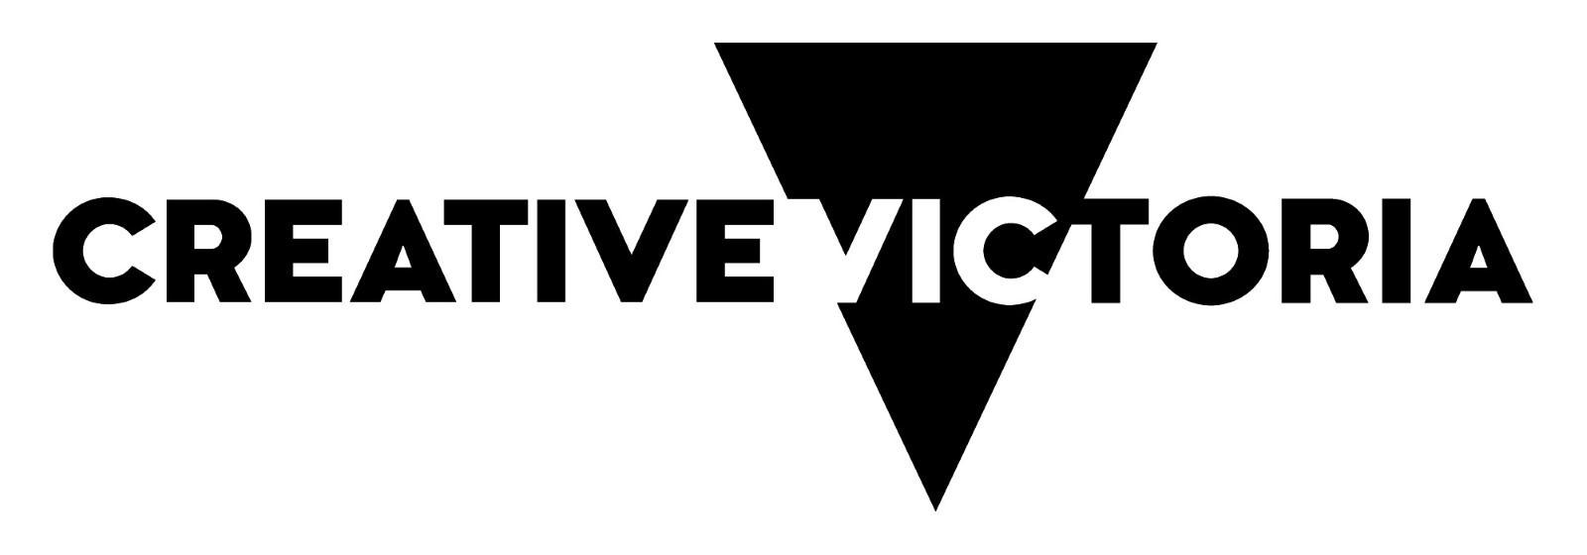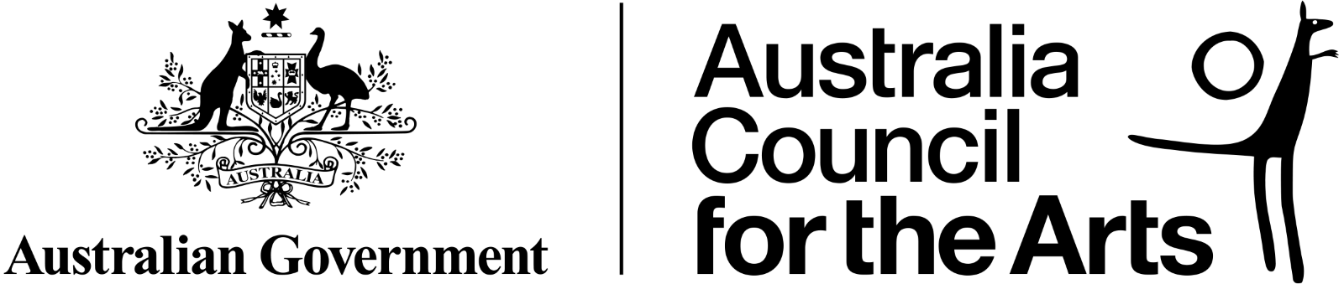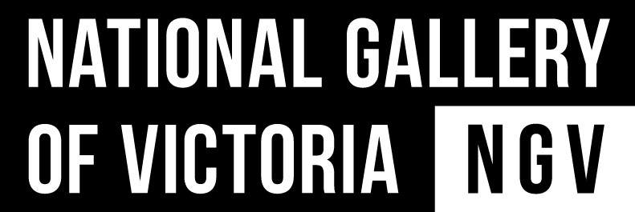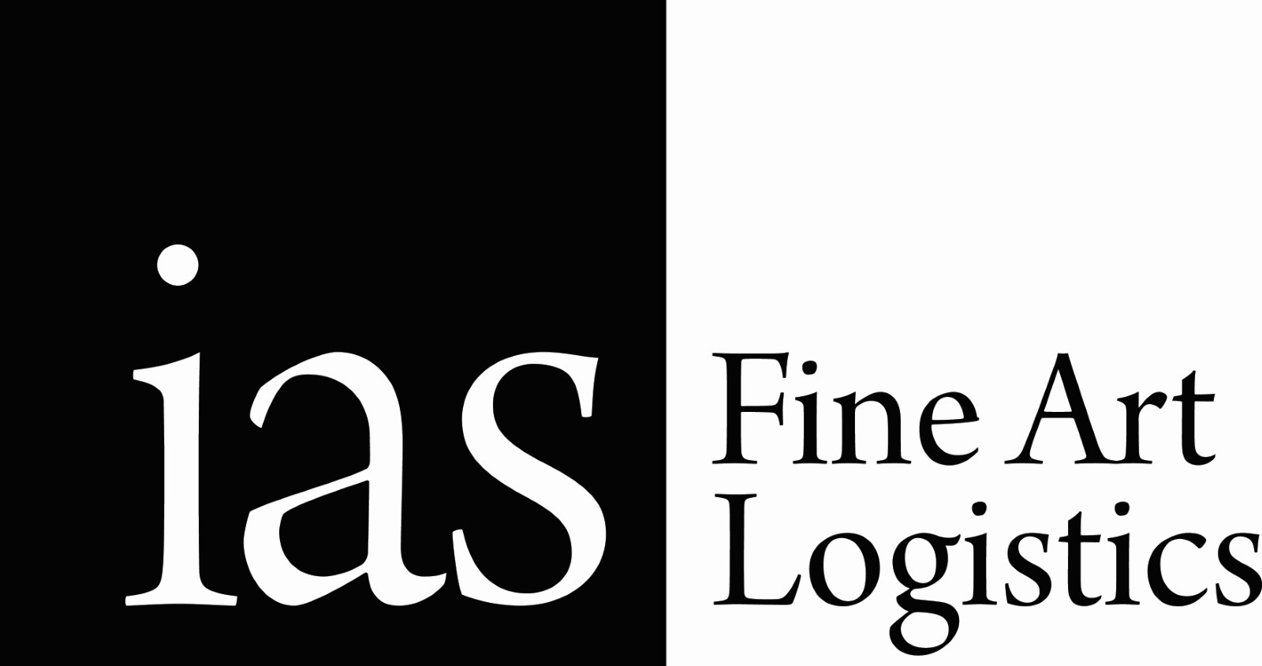

National Exhibitions Touring Support (NETS) Victoria is supported by the Victorian Government through Creative Victoria, by the Australian Government through the Australia Council, its arts funding and advisory body, and through the Visual Arts and Craft Strategy, an initiative of the Australian, State and Territory Government. NETS Victoria also receives significant in-kind support from the National Gallery of Victoria.

